**INTERPRETATIONS OF QUANTUM MECHANICS AND THE QUANTUM FUTURE**

Avanija Menon

Faris Saadat Yazdi

Nadia Athallah Praga

Saleh Saheb Razian

**Aim:** The aim of the project is to research and investigate the wide variety of interpretations of quantum mechanics and also the future possibilities and happenings of quantum discoveries, and analyse them and state any shortcomings or issues in them, and therefore link these interpretations with any future happenings in the field and explain them.

**Objectives:** (enable team members to split out the tasks and focus on the tasks that they are assigned)

* To provide an introduction of this complex topic by explaining and helping to visualise the double-slit experiment.
* To explore and analyse the various interpretations of quantum mechanics and state any paradoxes or issues with these interpretations.
* To link some of these interpretations to the future possibilities of quantum mechanics and offer explanations of the complex mechanisms of the same.

This research project aims to introduce the reader into the world of quantum mechanics by offering an explanation and an original visualisation (created by team member- Saleh Razian) of the double-slit experiment. By exploring the very introduction of quantum mechanics through this experiment, team members (Avanija Menon and Faris Yazdi) gained an insight into the complexities of the topic and were able to dwell into the analysis of the various interpretations and implications of quantum mechanics and state any paradoxes or issues in this topic of physics. After doing so, the team member (Nadia Praga) was able to research and draw lines between these interpretations and the bright future of quantum mechanics and offer an insight into the rich, diverse and promising future that this fascinating sections of physics can present the world with.

The purpose of this project is to communicate the various complexities of indeed a rather complex sector of physics in itself in simple language and educate the audience of how close humanity is to achieving accomplishments that were once thought to be fictional, by the comprehension of the interpretations to give them an idea of the various perspectives of quantum mechanics and then delving into the future, once deemed to be impossible.

**Approach:**  Research based project. Since the project is concerned with quantum mechanics, resources for an experimental approach for the quantum interpretations was limited, especially with a lack of mentor. However, Saleh Razian has created an animation of the visualisation of the double-slit experiment for clarity. The common approach used involves intensive research and data collecting from sources stated later on, and analysis of various findings and facts are included, since the team was more interested in the actual analysis and not the experimentation of quantum mechanics as we had a common strength, which was our research and analysis abilities. However, one might also take the experimental route and set up the actual double-slit experiment and arrive at a conclusion from the results established.

**Plan:**

Subtopics were delegated based one the team members’ strongest areas. Saleh Razian created an original visualisation of the double-slit experiment using code (listed below) since he is strong in the sector of computer science, while also doing a great deal of research to provide explanations of the experiment. Avanija Menon and Faris Yazdi delved into deep research of the interpretations, analysed the data they gathered and offered possible criticisms and implications of this data. All of this gathered data and information was crucial for the explanation of the ‘Future of quantum mechanics’. Nadia Praga was involved in the research and the comprehension of the complications of subtopics like quantum encryption and teleportation, receiving aid from the ‘interpretations’ of quantum mechanics. Time was allocated very carefully since we had AS level exams this year. Basic topic discussion and preliminary research started in December and work processes carried all the way through to mid-April. We had to counter the onslaught of frequent exams and tests from school by careful time management and each of us committed to working together in school to clarify any doubts and worked through significant amounts of time through weekends and most weekdays as well. Since exams started in May, we were required to divert our attention to the revision of exams. Exams finished in mid-June and the rest of June was devoted to any final editing and tuning of our project to minimise errors.

**Avanija Menon**: Acted as team leader. delegated the subtopics to the team members and ensured the efficient flow of the project. Involved in the explanation and analysis of the interpretations of quantum mechanics.

**Saleh Saheb Razian**: Created an original animation of the visualisation of the double-slit experiment. Involved in the explanation of the double-slit experiment.

**Faris Saadat Yazdi**: Involved in the explanation and analysis of the interpretations of quantum mechanics and the implication of ‘The Measurement Problem’. Aided another team member in the ‘Future of Quantum Mechanics’.

**Nadia Athallah Praga**: Involved in the research, explanation and analysis of the ‘Future of Quantum Mechanics’.

**THE DOUBLE-SLIT EXPERIMENT**

This rather famous experiment portrays quantum mechanics in a seemingly simplistic manner by portraying wave particle duality and ensuring the onlooker an insight into a section of physics that has been mind-boggling to many and fascinating to others. Beginning with this experiment fortifies a solid basic understanding of the subject before moving on to the many interpretations and theories that surround it.

When streams of particles such as electrons or photons pass through two narrow adjacent slits to hit a detector screen on the other side, they don't form clusters based on whether they passed through one slit or the other. Instead, they interfere: simultaneously passing through both slits, and producing a pattern of interference bands on the screen. This phenomenon occurs even if the particles are fired one at a time, showing that the particles demonstrate some wave behavior by interfering with themselves as if they were a wave passing through both slits.

Fundamental particles, such as photons and electrons, exhibit wave-particle duality by displaying wave or particle properties with respect to the experiment. Therefore, these particles can diffract, like waves, and counted discreetly, as particles.

In the double-slit experiment, fundamental particles (photons) travelling through two narrow adjacent slits behave like a wave. They enter both slits, (if unobserved*) diffract and interface with themselves until being detected by a screen on the other side, where the particle collapses into a fixed position; creating interference band.

Unlike fundamental particles, classical particles would travel in a straight light through the slits and would not diffract. As a consequence, the particles would not interfere with each other and would create 2 spikes of great concentration of particles, instead of interference patterns. This is because waves create interference patterns and not particles. This provides evidence that fundamental particles exhibit both particle and wave properties.

Calculations:

We can calculate the distance between the fringes created by the interference pattern by considering the following formula:

(Lamda)*(distance between the slit barrier and the screen) = (distance between the slits)*(distance between the fringes)

Experiment:

1. Fire a particle to a double slit onto a screen

2. Plot the position of the particle on a screen

3. Repeat

4. The particles form interference bands (showing Particle-Wave Duality)

The previous experiment was conducted in various settings and the production of the interference fringes was observed. The probability of where the particles land on the screen can be calculated using the previous classical wave formula. However, the particles do not arrive at the screen at any predictable order. Therefore, knowing the appearance and order of the particles on the screen does not provide us any information about the future particles which will be detected. In other words, the events in the past and the events in the future are independent from each other.

Note: The following code was written in Java and it is to be executed by Processing 3. Processing 3 can be downloaded from processing.org

**Code 1 for the animation:**

Description: Wave fronts pass through 2 slits, diffract and interfere with each other. Areas where the red (maxima) of the wave overlap, it becomes bright red and when a maxima and minima overlap, it becomes dark red.

void **setup**(){

size(600,600);

background(0);

}

int t=0;//Time

int m =0;//Distance between the wave front and the slit ("movement")

float w=0;//Magnitude of the "wave"

float theta = 10.3; //lambda/(distance between slits)

void **draw**(){

clear();

for (int i=0;i<600;i+=3){

w = cos(radians((i-t)*10));//Magnitude/Phase of the "wave"

stroke(255*w,0,0,125);

strokeWeight( 4 );

if (i<200){

if (w>0) {

line(i,0,i,600);//The incoming wave-fronts

}

}

fill(0,0);

m = (i*2)-36;

arc(200,400,m,m,radians(270+theta),radians(450-theta));//Slit 1

arc(200,200,m,m,radians(270+theta),radians(450-theta));//Slit 2

}

t+=5;

}

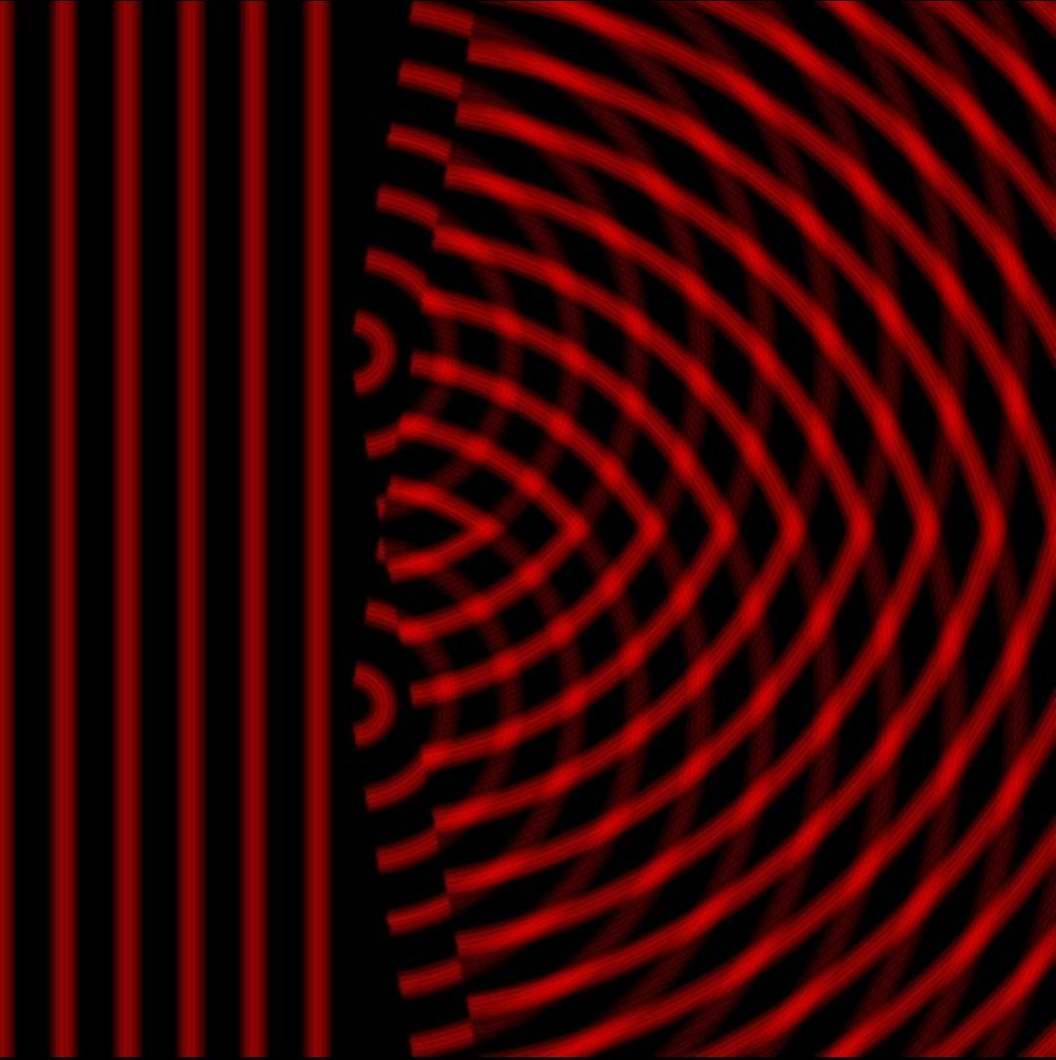

**Code 2 for the animation:**

Description: Similar to code 1; however, This code is more sophisticated and allows you to change the distance between the slits and the distance between the source and the slits barrier. The code can produce waves for any given sized window.

void **setup**(){

size(600,600);

background(0);

frameRate(4.5);

}

float t=0;//Time

float wall=0;//Barrier

int bar;//The largest distance between the source and a barrier/screen end

float shrink;//The size of the arc

float shrinkslit;//The size of the arc in the double slit

float slitpos;// the position of the slits

float str;//Storage to contain the value of the wave

void **draw**(){

clear();

strokeWeight(4);

wall=mouseX;//the x value of the mouse on the screen

bar=(int)sqrt((float)(Math.pow((height/2),2)+(Math.pow(wall,2))));// c^2 = a^2 + b^2

for (float pos=0;pos<(bar);pos+=10){//pos is the diameter of the circles from the source

str=sin(radians((pos-t)*10));

if (str>=0){//Ignoring the minimas since the background is black and the minima are black

stroke(255*str,0,0,125);

fill(0,0,0,0);

if (pos>(height*2)){

shrink=(float)((Math.acos((height*2)/pos)));//if pos<(height*2) shrink=undefined

}

else{

shrink=0;

}

arc(0,height/2,pos*2,pos*2,PI+HALF_PI+shrink,TWO_PI+HALF_PI-shrink);//drawing arcs within the boundaries of the window screen

t++;

}

}

stroke(0);

fill(0);

rect(wall,0,width-wall,height);//hiding the extra bits of the wave

slitpos=mouseY;

if (slitpos>300){

bar=(int)sqrt((float)(Math.pow(height-slitpos+300,2)+(Math.pow(width-wall,2))));

}

else{

bar=(int)sqrt((float)(Math.pow(height-slitpos,2)+(Math.pow(width-wall,2))));

}

for (float pos=0;pos<(bar);pos+=10){

str=sin(radians((pos-t)*10));

stroke(255*str,0,0,125);

fill(0,0,0,0);

if (pos>(slitpos*2)){

shrink=(float)((Math.acos((slitpos*2)/pos)));

}

else if(pos>((height-slitpos)*2)){

shrinkslit=(float)((Math.acos(((height-slitpos)*2)/pos)));

}

else{

shrink=0;

shrinkslit=0;

}

arc(wall,slitpos,pos*2,pos*2,PI+HALF_PI+shrink,TWO_PI+HALF_PI-shrinkslit);

arc(wall,height-slitpos,pos*2,pos*2,PI+HALF_PI+shrinkslit,TWO_PI+HALF_PI-shrink);

t++;

}

}

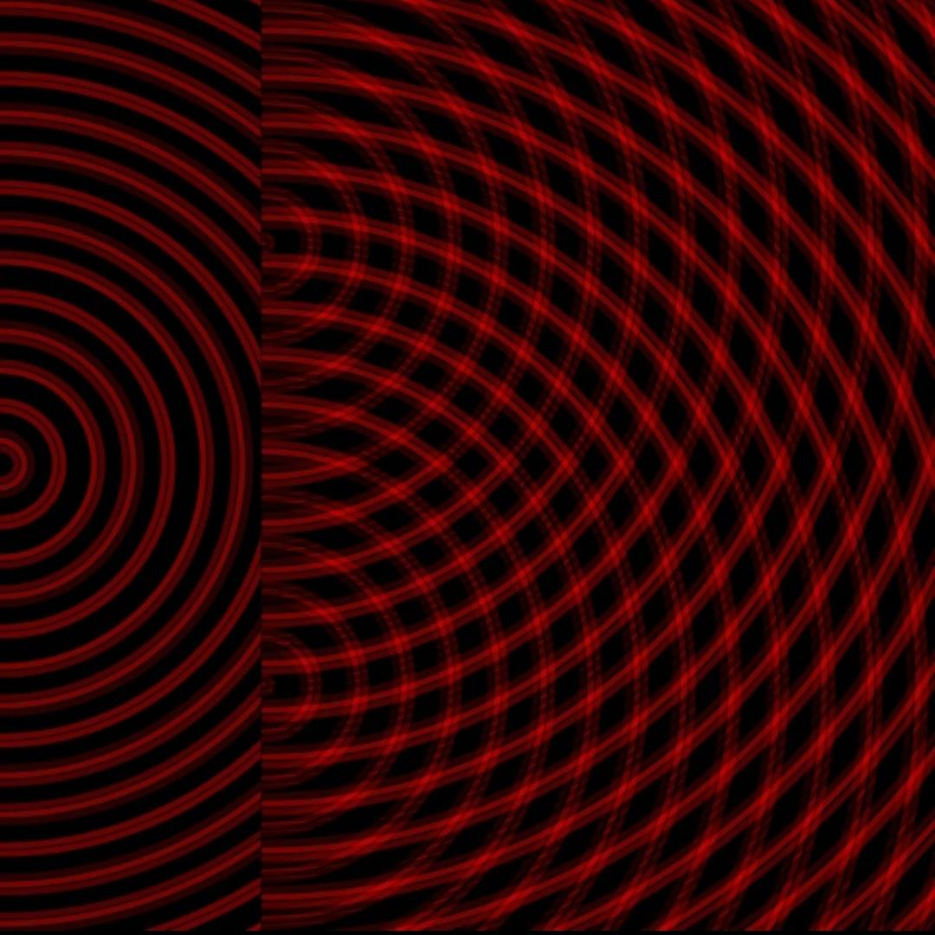

Sources:

[Wave–particle duality - Wikipedia](https://en.wikipedia.org/wiki/Wave%E2%80%93particle_duality#Heisenberg's_uncertainty_principle)

[Wave-Particle Duality | Brilliant Math & Science Wiki](https://brilliant.org/wiki/wave-particle-duality/#)

[Wave Equation | Brilliant Math & Science Wiki](https://brilliant.org/wiki/wave-equation/)

[Elementary particle - Wikipedia](https://en.wikipedia.org/wiki/Elementary_particle)

[Double-slit experiment - Wikipedia](https://en.wikipedia.org/wiki/Double-slit_experiment#Computer_simulations)

[Physics in a minute: The double slit experiment | plus.maths.org](https://plus.maths.org/content/physics-minute-double-slit-experiment-0)

[The Logic-Defying Double-Slit Experiment Is Even Weirder Than You Thought](https://www.popularmechanics.com/science/a22280/double-slit-experiment-even-weirder/)

[What Does the New Double-Slit Experiment Actually Show? - Scientific American Blog Network](https://blogs.scientificamerican.com/guest-blog/what-does-the-new-double-slit-experiment-actually-show/)

[Thomas Young's Double Slit Experiment](https://www.thoughtco.com/youngs-double-slit-experiment-2699034)

[Double-slit Experiment | Brilliant Math & Science Wiki](https://brilliant.org/wiki/double-slit-experiment/)

[The Double-Slit Experiment Cracked Reality Wide Open](https://curiosity.com/topics/the-double-slit-experiment-cracked-reality-wide-open-curiosity/)

[Two-Slit Experiments](http://abyss.uoregon.edu/~js/21st_century_science/lectures/lec13.html)

[The Double Slit Experiment Demystified. Disproving the Quantum Consciousness connection](https://medium.com/@roblea_63049/the-double-slit-experiment-demystified-disproving-the-quantum-consciousness-connection-ee8384a50e2f)

[Young’s Double Slit Experiment – College Physics](https://opentextbc.ca/physicstestbook2/chapter/youngs-double-slit-experiment/)

**INTERPRETATIONS**

Copenhagen Interpretation

This interpretation was expressed to seek the meaning of quantum mechanics and was devised by Niels Bohr and Werner Heisenberg from 1925 to 1927. It proposes that a quantum particle does not exist in just one state or another, but in all of its possible states at once. Physical systems, according to this interpretation, does not have fixed properties before the acts of measurement and observation, and that quantum mechanics just serves to predict the probabilities that the measurements might produce specific results. Due to wave function collapse (when a wave function, initially in several eigenstates, appears to reduce to a single eigenstate soon after its interaction with the external world, or an observation), the set of probabilities minimised to just one possible value.

This interpretation lies in accordance with the double-slit experiment and the observer effect and provides a reason as to why the quantum particles behave strangely. Observing a particle causes the particles to form a pattern with just the expected two lines and not an actual wave interference pattern. This has resulted in the popular belief that a conscious mind can directly affect reality. However, the act of observations means the extraction of information, Therefore, it is not rooted in the depths of human consciousness at all. Extraction of information means interaction and the Newtonian laws of physics have been built on the foundation that one can observe a system passively. On the contrary, this passive observation is not applicable to quantum mechanics. The simple act of seeing involves photons, specifically, the reception of photons. These photons transfer energy and henceforth interact with the particles in the double-slit experiment. Since the double-slit experiment measures entanglement, the connection of the photons and the particles can cause the experiment to be altered through the mere act of observation.

Sources:

<https://www.quora.com/In-the-double-slit-experiment-what-does-it-mean-to-observe-the-particle>

<https://en.wikipedia.org/wiki/Observer_effect_(physics)#Quantum_mechanics>

<https://en.wikipedia.org/wiki/Double-slit_experiment#Copenhagen_interpretation>

<https://science.howstuffworks.com/innovation/science-questions/quantum-suicide4.htm>

Pilot Wave Interpretation

Also known as Bohmian mechanics, this theory was first brought into light by Louis de Broglie in 1927 and it interprets quantum mechanics as a deterministic theory and introduces nonlocality. In this interpretation, every electron has a determined, definite position. An electron is guided and moved around by a ‘pilot wave’ which obviously plays a major role in the electron’s position. While the mentioned pilot wave passes through both slits simultaneously, an electron can only travel through one slit at a specific time.

However, the Pilot Wave interpretation is not rather celebrated among physicists and the mainstream tends to give more importance to the Copenhagen interpretation and the Many Worlds interpretation. A factor contributing to this was caused by a paper known as ‘ESSW’ (an acronym manufactured by the names of its authors). The paper stated that particles cannot follow the simple Bohmian trajectories as they travel through the double slits. ESSW showed that a photon could pass through the left slit but the experimental record would show that the photon had, in fact, passed through the right slit.

Supporting this interpretation is a paper published by Aephraim Steinberg and his colleagues when they performed the ESSW experiment which is supposedly a ‘fatal blow’ to the Pilot wave theory as a whole. Steinberg and his colleagues confirmed that the photon trajectories are not surrealistic as the mainstream states them to be, however they may seem surrealistic if one does not take into account the nonlocality of the interpretation. The experiment conducted by the group is a parallel to the standard double-slit experiment, however, instead of using electrons they used photons and additionally, instead of sending the photons through the two slits, they passed them through a beam splitter (an optical device that splits a beam of light into two. Hence, it directs a photon along one of two paths, depending on the photon’s polarization - a quantum mechanical description of the polarized sinusoidal plane electromagnetic wave frequent in classical mechanics). These photons then reach a single-photon camera (which acts in the same way as the screen in the original experiment) that records their final position. Another difference that sets this apart from the traditional experiment is the fact that more importance is given to the actual path the photons take from the choice of two rather than which slit the particle has passed through.

Another important element of this experiment is quantum entanglement. The researchers fulfilled this by using pairs of photons that are connected to each other, or in other words - entangled, rather than independent photons. Each photon possesses knowledge of the other and henceforth information about one of the photons can be achieved if the other is at reception. In essence, when the first photon passes through the beam splitter, the second photon knows which path the first photon took and this information could be used to essentially track the first photon’s path. Each indirect measurement brings about only an approximate value, but the average of a large number of measurements can be taken to reconstruct the trajectory of the first photon.

However, Goldstein and his team did admit that the paths of the photon indeed appear to be surreal as the ESSW stated: A photon would sometimes strike one side of the screen, even though the polarization of the entangled partner mentioned that the photon took a different route. There is indeed an explanation for this strange phenomenon.In the beginning, immediately after the first photon passes through the beam splitter, the second photon has a strong ‘memory’ of which slit it went through. But as the distance between the photons increases, the less reliable the second photon’s report becomes. This is caused by nonlocality. As the two photons are entangled, the path that the first photon takes will definitely affect the polarization of the second photon. By the time the first photon reaches the screen, there is a high probability that the second photon’s polarization will be affected the other way - essentially we do not get an ‘opinion’ from the second photon and hence we would not know which path the first photon took. Steinberg mentioned that Bohm trajectories themselves aren’t ‘surreal’, the problem lies within the second photon which gives the information that the trajectory of the first photon is ‘surreal’. Most often, the element of nonlocality is forgotten or deemed irrelevant, hence the whole idea of Bohmian mechanics is shunned as being surreal when only the information of the second photon is surreal.

Sources:

<https://www.quantamagazine.org/famous-experiment-dooms-pilot-wave-alternative-to-quantum-weirdness-20181011/>

<http://advances.sciencemag.org/content/2/2/e1501466>

<https://www.degruyter.com/view/j/zna.1992.47.issue-12/zna-1992-1201/zna-1992-1201.xml>

<https://en.wikipedia.org/wiki/Photon_polarization>

<https://www.quantamagazine.org/pilot-wave-theory-gains-experimental-support-20160516/>

Many Worlds Interpretation

This rather peculiar interpretation suggests that there exists an infinite number of universes, all superimposed in the same physical space, however there is no mutual interaction and are completely independent in terms of evolution and advancement. More specifically, it brings into light the objective reality of the universal wavefunction and denounces the actuality of wave function collapse, which occurs when a wave function which is initially in a superposition of several eigenstates, reduces to one eigenstate due to observation. This interpretation omits the possibility of randomness in the quantum theory and in the entirety of physics as well, as, if the other predicted events do not happen, it is because those events are happening in other worlds. Hugh Everett, the physicist who proposed the theory stated that the human concept of reality is at fault and that we only expect a single outcome of a measurement. However, all of them do occur and we only see one of these realities and that does not mean that other realities do not have a physical existence. Essentially, there is an implication that all possible realities are inherent in one wave function. This wave function is created by the superposition of its constituent particles. This causes the realities to be significantly different from each other.

The Many Worlds interpretation is quite celebrated publicly as it states that there is no path left untaken. This theory is simply just a deduction from the hypothesis that all paths of a particle are real. Hence, technically, any interaction between a quantum entity and a particle demands produces alternative outcomes and, therefore, demands many parallel universes.

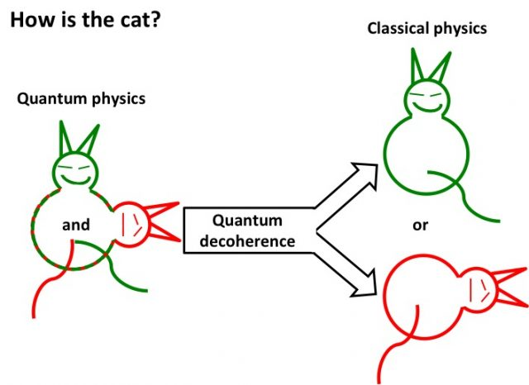

Universes split due to quantum decoherence. Decoherence is described as the process by which bodies and quantum systems lose some of their unusual quantum properties (an example is superposition) as they interact with their environments. When a particle decoheres, its probability wave collapses, any quantum superpositions disappear and it settles into its observed state under classical physics. Parallel quantum worlds split once decoherence occurs as the decohered wave functions can possibly have no direct influence on each other. However, the splitting is not instantaneous. It evolves through decoherence and is only complete when decoherence has removed all possibility of interference between the universes.

Sources:

<https://www.physicsoftheuniverse.com/topics_quantum_superposition.html>

<https://www.quantamagazine.org/why-the-many-worlds-interpretation-of-quantum-mechanics-has-many-problems-20181018/>

The act of measuring is very important as revealed by say the double slit experiment and its measuring variant. Measuring can be loosely phrased as the escaping of information from a particle to the ‘outside world’, consider the two following examples: if we have a particle whose position we want to know, if we shoot another particle at it (ignore uncertainty and transfer of momentum) we can find out its position from the angle that the shot particle gets reflected at (the small particle is entangled with the larger), therefore if you measure the small particle then we have effectively measured the one whose position we wanted, in this sense the information escaped into the outside world; now consider if we have a particle on a track so that only one of its directions are unknown, then if we shoot a made up particle that passes through but changed colour then we have not made a measurement if we observe the coloured particle because regardless of the position we know that the colour would have changed anyway so no information is gained.

One of the main problems in all of quantum mechanics (including all interpretations so far) is that it is not clear how to interpret the wavefunction. Some take a realist approach and hope for a physical phenomenon of sorts to encode this information physically while others declare that it is purely mathematical and is just a means of computation that turns out to give experimentally verified outcomes.

Pilot wave theory (aka de Broglie-Bohm theory) is a hidden variable theory (because the position and momentum of any given particle is unknowable due to measurement changing the state of the system) and is thus deterministic and also follows realism. It uses the concept of a guiding ‘pilot wave’ as a way to go against the idea of inherent randomness that is found in Copenhagen’s standard interpretation. One common criticism is that the pilot wave has no physical explanation and is just a mathematical object that gives results that we expect to see, perhaps it hints at the existence of a separate field in which pilot waves exist.

The Measurement Problem

The measurement problem entails the issue of how wave function collapse occurs and what it is physically. It has been summarised by physicists as "How can one establish a correspondence between quantum and classical reality?".

Many worlds interpretation bypasses the measurement problem because it states that wavefunction collapse is simply the branching of the worlds instead of a phenomenon that changes the state of the quantum particles. Also the wavefunction is a total representation of all possible future states in which all of them occur, this gives all possible realities the same status and the one we experience has no greater importance than the others.

Other interpretations, especially ones that do not suggest realism (eg. Copenhagen’s interpretation) get criticism for this very problem because it highlights the ambiguity of what a measurement entails and when wavefunction collapse occurs. Realism ‘tames’ the measurement problem because then we have that a measurement does not change reality then wavefunction collapse is not a physical change and the measurement problem is no longer meaningful.

**FUTURE OF QUANTUM**

Quantum teleportation

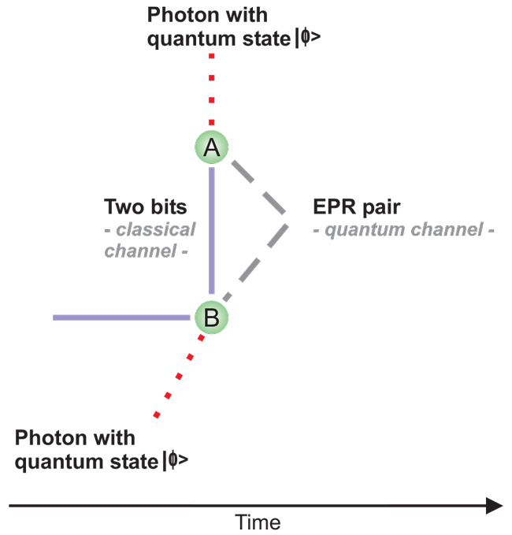

Quantum teleportation is not seen as a futuristic possibility anymore, but as a reality, as it has been done successfully, most famously by Jian Wei Pan, over a distance of 1400 km from a satellite to Earth in June 2017.

Quantum teleportation works by using quantum entanglement. In a situation where two particles (we will name the first particle ‘A’ and the second particle ‘B’ for simplicity) that are entangled with each other encompassing a large distance between each other, A is given a third particle (C) that one would want to teleport. C is then entangled with A and the quantum state (or quantum bit or qubit) of C is then extracted by A, which would result in the destruction of C, and is sent to B. B then is made to construct C using the qubit it has received using a different set of fundamental particles than prior.

Quantum state is an energy so it sends energy and then B will be able to make photon which is made out of energy.

Unlike the usual quantum entanglement, where measuring a particle of an entangled pair, influences the other particle instantaneously, quantum teleportation is not the same as it sends information unlike the former. The former allows superluminal motion as it does not defy Bell’s theorem of locality (Bell's theorem asserts that if certain predictions of quantum theory are correct then our world is non-local. "Non-local" here means that there exist interactions between events that are too far apart in space and too close together in time for the events to be connected even by signals moving at the speed of light) nor Einstein’s special relativity, as long as it does not transfer information, orientation influences are allowed to travel faster than light. However since teleportation involves the transfer of qubits of a particle’s state (aka information), this forbids teleportation to be faster than light.

Furthermore, the third particle is required to be destroyed during extraction of its quantum state for it to be teleported so for it to not defy the No-cloning theorem articulated by James Park, which essentially stated that it is impossible to create an identical copy of an unknown quantum state.

Though teleportation for photons, electrons, atoms and even calcium atoms seem attainable, teleporting human beings will be a long way as it involves many more atoms. And even if it does happen, the argument of consciousness have sparked. The teletransportation paradox suggests that when a being teleports, the original being’s atoms are destroyed and the information is sent and then the being is reconstructed but with different sets of atoms. The post-teleported being might have the original consciousness or will it be that the original being dies and then new life is made for the post-teleported being, however some argue that consciousness is already nonpersistent and that at each instant a new consciousness is replaced with all the same memories. Thus it is evident that the moral issues, regarding teleportation, are murky.

Sources:

<https://en.wikipedia.org/wiki/Quantum_teleportation>

<https://en.wikipedia.org/wiki/No-cloning_theorem>

Quantum Mechanics for Dummies - LondonCityGIrl - knowledge

<https://en.wikipedia.org/wiki/Teletransportation_paradox>

<http://www.scholarpedia.org/article/Bell%27s_theorem>

Time travel

In 2012, a philosophy professor named Huw Price, supported the idea of quantum retrocausality theory by suggesting that retrocausal influence must exist in quantum theories that assume quantum state is real and that the quantum world is time-symmetric.

For the results of the Bell’s tests, this theory explores an alternate interpretation of the test. In an entangled pair of particles of when you affect particle B, you affect particle A instantaneously; Einstein called it “spooky action at a distance” and that the effect would “break” the law of locality as some would say (however it does not, as locality only refers to sending information and in this situation no information is transferred therefore locality is conserved). In the theory of retrocausality, when a particle is observed, particle B would go back in time to the moment it was first created and take that spin in that moment and affect particle A.

This relates to the Copenhagen Interpretation as superposition is needed for this theory, unlike the pilot-wave theory the quantum state of the particle is indefinite. This also opposes with the many worlds interpretation as instead of the particle having many directions of spin at once, many-worlds suggests many particles that each reside in a distinct parallel universe with the particles not sharing the same spin even though each individual has a single spin.

This theory depends on the existence of time symmetry. As according to the second law of thermodynamics which states that “the total entropy of an isolated system can never decrease over time, which would make time asymmetrical”, this forbids the theory to happen. However the aforementioned law happens in classical physics and the quantum world may be different as many quantum theories (apart from the retrocausality theory) assumes time symmetry exists.

If this theory proves to be right, time travel might be possible in the near future.

Sources:

<https://en.wikipedia.org/wiki/Quantum_mechanics>

WTF is Quantum Retrocausality (ft. Physics Girl) -Seeker

This particle breaks time symmetry - veritasium

<https://phys.org/news/2017-07-physicists-retrocausal-quantum-theory-future.html>

Quantum Encryption

By using quantum cryptography (or quantum key distribution) to send information between a sender and a receiver, security is guaranteed. Propose a given situation of a sender wanting to send information to a receiver but with no possibility of a third party, an “eavesdropper”, spying nor decoding the message. The sender would want to code the message in such a way that it is easy to code also, paradoxically, difficult to decode; like a one-to-many function.

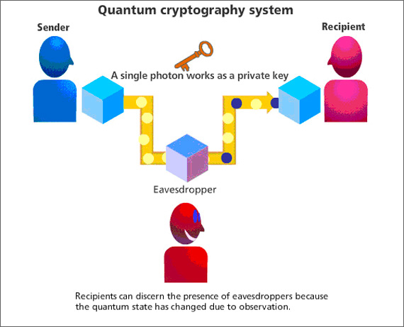

The sender would have a set of particles and the receiver has the pairs of the aforementioned set (paired in a quantum entanglement). The set would contain photons with each of the photons having different spins relative to the message. The receiver would measure each of the photon’s spins by using polarised detectors. As the spin would either be left, right, up, down, diagonal to any direction, the result of the measurement will only be either up or down (depending on how the detectors is set, the results can be only left or right, etc). These results would then be translated into qubits with binary numbers, and the message would be decoded. If the eavesdropper tries to tamper or spy on the photons, the observer effect would collapse the superposition state of the photons and the photon polarisation would change as well and the sender and receiver would know their message has been tampered with.

Quantum encryption relates to the Copenhagen interpretation as it relies on the idea that the particles (both the particles in an entangled pair between sender and receiver) have a superposition. This superposition in this sense is the spin of the particles. And by measuring the spin of the particles when trying to decode the message using the polarised detectors, the superposition collapses resulting with the particle having a definite spin and the message is revealed. When the eavesdropper observes the particles, the superposition collapses as well and the degree of the spin changes.

With the rise of computational advancements, decoding cryptic messages is getting increasingly easier and with this technique, security is guaranteed as cybersecurity has been a concern for individuals. This method would be extremely useful to maintain privacy in banking assortments, transferring private messages and such.

This system has been in practice, in China more specifically. A quantum link has been made from Beijing to Shanghai, a distance of well over 1900 km, by using fibre optic cables to transmit photons with quantum repeaters (a relay node which decrypt and encrypt the photon) along the cable, with several banks already using this technology to send certain messages.

On September 2017, the first video call that was secured by quantum encryption was held between Anton Zeilinger and Jian Wei Pan from Beijing, China to Vienna, Austria spanning a distance of 7,400 km. This was done by sending photons from satellite named Micius to the Xinglong Observatory (Beijing) and sending the other entangled pair to Austria.

As these are novice technologies, implementing quantum key distribution in our daily lives in the near future will become more practical.

Sources:

<https://en.wikipedia.org/wiki/Quantum_key_distribution>

<https://www.insidescience.org/news/china-leader-quantum-communications>

<https://en.wikipedia.org/wiki/Quantum_cryptography>

Quantum Cryptography Explained - Physics Girl

<https://physicsworld.com/a/secure-quantum-communications-go-the-distance/>

Quantum mechanics is admittedly a fairly new science, its basics coined as recently as the 20th century. It has embedded in it, several mind-boggling complexities, intricate details and great depths, agreeing with Richard Feynman’s quote: ‘If you think you understand quantum mechanics, you don’t understand quantum mechanics’, which clearly reveals the complexity of the quantum world, explained by the various interpretations like Copenhagen and Many Worlds for what was essentially one experiment. Since, this sector of physics is fairly new, we as a species have a lot more to accomplish and achieve in quantum mechanics and yet, surprisingly, new doors to a revolutionary world of a quantum ruled world have been opened, revealing several discoveries in its authenticity and converting what was one thought to be fiction into fact, which was proved by the explanation of quantum teleportation and time-travel.